**Project Design Phase-II**

**Data Flow Diagram & User Stories**

|  |  |
| --- | --- |
| Date | 19 October 2022 |
| Team ID | PNT2022TMID52614 |
| Project Name | Project – Containment zone alerting app |
| Maximum Marks | 4 Marks |

**Data Flow Diagrams:**

A Data Flow Diagram (DFD) is a traditional visual representation of the information flows within a system. A neat and clear DFD can depict the right amount of the system requirement graphically. It shows how data enters and leaves the system, what changes the information, and where data is stored.

Example: DFD Level 0 (Industry Standard)

**Example:** [**(Simplified)**](https://developer.ibm.com/patterns/visualize-unstructured-text/)

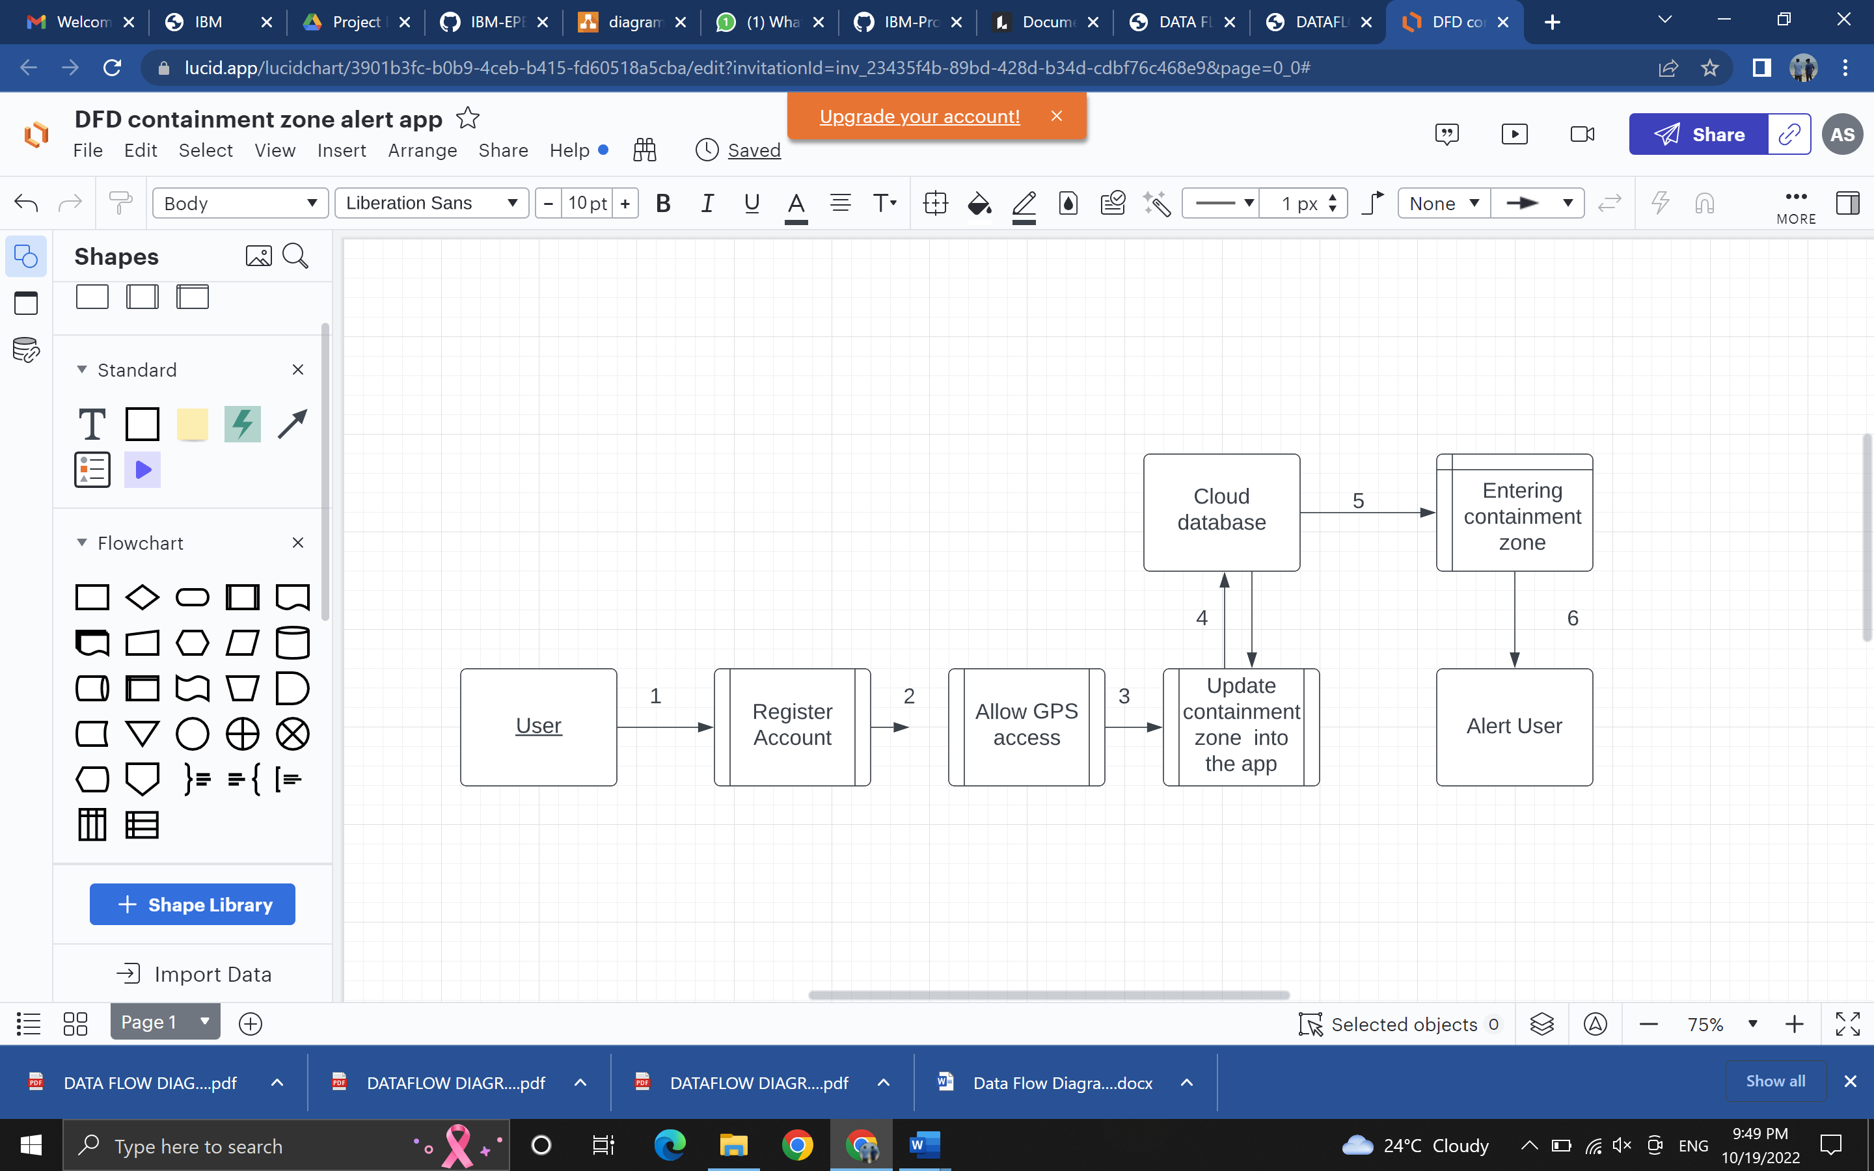

1. **User will register an account.**
2. **Then user should allow the app to access his/her GPS.**
3. **Then app will update all the containment zone near the user.**
4. **App will keep updating containment zone by accessing cloud**

**database.**

1. **Then if the user enters the containmenrt zone(gets location**

**from cloud)**

1. **Alert the user through pushing notifications.**

**User Stories**

Use the below template to list all the user stories for the product.

| **User Type** | **Functional Requirement (Epic)** | **User Story Number** | **User Story / Task** | **Acceptance criteria** | **Priority** | **Release** |
| --- | --- | --- | --- | --- | --- | --- |
| Customer (Mobile user) | Registration | USN-1 | As a user, I can register for the application by entering my email, password, and confirming my password. | I can access my account / dashboard | High | Sprint-1 |
|  |  | USN-2 | As a user, I will receive confirmation email once I have registered for the application | I can receive confirmation email & click confirm | High | Sprint-1 |
|  |  | USN-3 | As a user, I can register for the application through Facebook | I can register & access the dashboard with Facebook Login | Low | Sprint-2 |
|  |  | USN-4 | As a user, I can register for the application through Gmail |  | Medium | Sprint-1 |
|  | Login | USN-5 | As a user, I can log into the application by entering email & password |  | High | Sprint-1 |
|  | Dashboard | USN-6 | As a User , Can I manually plot the alerted zone for my convenience only. | It can be viewed in the user dashboard | Low | Sprint-2 |
| Customer (Web user) | Registration | USN-7 | As a user, I can register for the application by entering my email, password, and confirming my password. | User account activities can be viewed in dashboard. | High | Sprint-2 |
|  |  |  | Confirmation code has been send through the registered mail id, phone number |  |  |  |
|  | Location Access | USN-8 | As a User , I can viewed into the page , if there is any condition to access the location. | Location can be turned through Control centre. | High | Sprint-2 |
|  | Contaminated Zones | USN-9 | Is it accurately show off the alerted zone If I Entered into the zone the messages are properly received through email. | Alerted messages are send by send grids through the registered mail id. | High | Sprint-3 |
| Administrator | Frequent Updates | USN-10 | Admin are necessary to updates the recent containment through their portals and these seen through the app. | It can be accessed by Geo fencing. | Medium | Sprint-4 |
| Hospital Administrator | Registration | USN-11 | As a management, I need to register my hospitals on the site. | I can see the registered hospital in the hospital dashboard. | High | Sprint-1 |
|  | Login | USN-12 | As a management, I need to login into my dashboard with my given hospital id and password. | I can see my dashboard after login. | Medium | Sprint-1 |
|  | Dashboard | USN-13 | As a management, I need to enter the case information of the patient that visits our hospital. | I can view the patient information on the dashboard. | High | Sprint-2 |
|  |  | USN-14 | As a management, I need to store all the patient information on the cloud. |  | High | Sprint-2 |
| Administrator | Services | USN-15 | As an admin, I need to provide valid information about the pandemic out there . | I can get the pandemic updates out there. | High | Sprint-2 |
|  |  | USN-16 | As an admin, I need to provide medical advice through a chatbot. | I get medicinal recommendations through a chatbot. | Medium | Sprint-3 |
|  |  | USN-17 | As an admin, I need to provide medical recommendations by collaborating with top hospitals. | I get medical instruction through chief doctors. | Low | Sprint-3 |
|  |  | USN-18 | As an admin, I need to alert the user when they enter pandemic zones. | I got a notification when I am in the pandemic area. | Medium | Sprint-4 |
|  |  | USN-19 | As an admin, I need to provide preventive measures when they travel through it. | I got a remedies notification when I am in the pandemic area. | High | Sprint-3 |
|  |  | USN-20 | As an admin, I need to provide special services for premium users by giving services like monitoring health by their smart bands. | I was treated special after becoming a premium member. | Low | Sprint-4 |
|  | Data Collection | USN-21 | As an admin, I need to store all the user information on the cloud. | I can access my information when I needed. | Medium | Sprint-4 |